Case 12-US-TN-Hale’s Point-Mississippian Effigy-Ceramic-1200-1400 CE

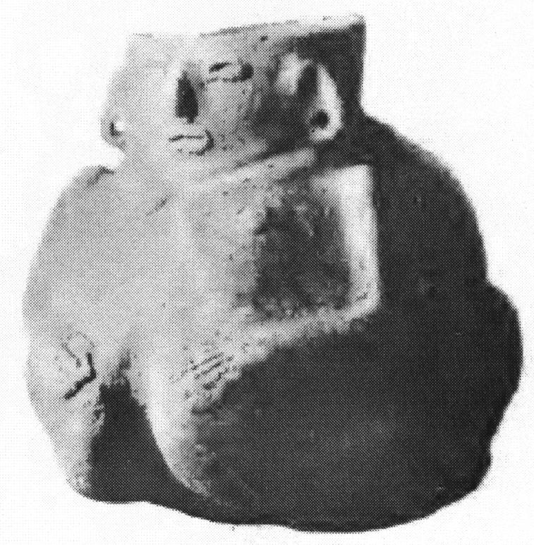

Human effigy ceramic bottle 6.73 in. high, Middle Mississippian Period (A.D. 1200 – 1400) with "the face of the figure being in relief on the neck of the bottle" (Moore 1916, 496). Right: Map of Middle Mississippi area with Hale's Point underlined (after Moore 1916: 492).

Reference:

**Case No.:**

**Accession Number:**

**Formal Label:**

**Display Description:**

**LC Classification:**

**Date or Time Horizon:**

**Geographical Area:**

**Map:**



**Map showing Hale’s Point, TN, after Moore 1916.**

**GPS Coordinates:**

**Cultural Affiliation:**

**Medium:**

**Dimensions**:   
**Weight:**

**Provenance:**

**Condition:**

**Discussion:**

**References:**

Clarence B. Moore, Some aboriginal sites on Green River, Kentucky (Philadelphia, 1916), p. 496, Fig. 25.